* Restarting the whole stack on laptop (to verify everything works and to converse vm time)

Steps:

1. Establish ngrok authorization (only have to do this once / system):

./ngrok authtoken 1QmY3tJn12ZvcLlNeb4D5MNUA0W_23VYgF9vh57QgDLcZu8yN

1. ngrok to create tunnel Rasa -> FM

.\Ngrok http -subdomain=karmaai 5005

Result: <https://karmaai.ngrok.io>

1. ngrok to create tunnel Flask -> FM

.\Ngrok http -subdomain=webviewfm 5000

Result: <https://webviewfm.ngrok.io>

1. resynced actions.py (going to get back to any dev being done on laptop)
2. start flask server (powershell):

& ".\run_flask.ps1"

1. Start rasa server (powershell):

& ".\rasa_run_server.ps1"

1. Start python for custom actions from Rasa (powershell):

& ".\rasa_run_actions.ps1"

1. Test flask-served page: <https://webviewfm.ngrok.io>
   * 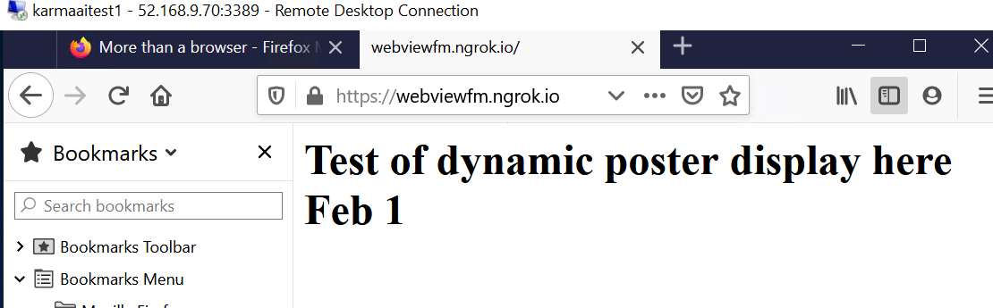
2. Validate webhook callback URL and token in Facebook app using ngrok-supplied static URL:
   * 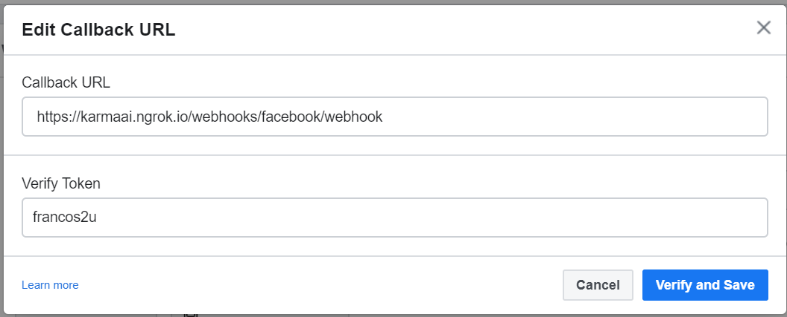
3. On mobile device, clean out MM conversation (click on MM icon -> Delete conversation); then go to messenger, search for MM, click on start button then “hi” -> genre -> comedy -> Deadpool -> URL button to see dynamic web page being served in webview: